CS 622
Discrete Mathematics, Data structure and introduction to algorithm
PE09 Programming Exercise Assignment
School of Technology & Computing (STC) @City University of Seattle (CityU)


Before You Start
- If you have questions about the lab requirements, please ask a TA to clarify for you.
- If you cannot solve the problem after a few tries, ask a TA for help.

Programming Assignment: Hash tables using linked lists

Description:
This assignment is to gain knowledge on hash tables using a linked list. A grocery store inventory manager will be implemented for this exercise. The program stores inventory items in hash tables. Your task is to define hash table in linked list in a separate file such as "hash_grocery_store_inventory.py," where it contains FileNameClass class(es) with essential methods for data manipulation. Note that "grocery_store_inventory.py" with the "main" method has already been provided.

As part of the assignment, compare the actual runtime of hash table operation as N size (N=10,50,100,250,500) increases and analyze its performance in a short paragraph. Keep in mind to always comment and document your class and methods.

Documentation reference:
- Mertz, J. (n.d.). Documenting Python Code: A Complete Guide. https://realpython.com/documenting-python-code/

Expected result:
- grocery_store_inventory.py:
- This is the Main python file that is already provided and contains the main and test procedure, which calls methods implemented on "simple_array_grocery_store_inventory.py" or "hash_grocery_store_inventory.py" file to manage inventory items (this is already provided, but please include this file on your submission).

- hash_grocery_store_inventory.py
- This is a file that includes the class of hash tables based inventory manager. This class contains such methods as init, insert_item, print_items, find_item. In addition, this class requires the inner class to hold onto hash tables data as a linked list. Please keep in mind the following notes for each method during implementation:
  - Example illustration: hash tables based inventory structure should look like the diagram below, where each array slot is used to contain a linked list. Each item and price is stored as objects in the linked list. Each node holds onto the item name and price.

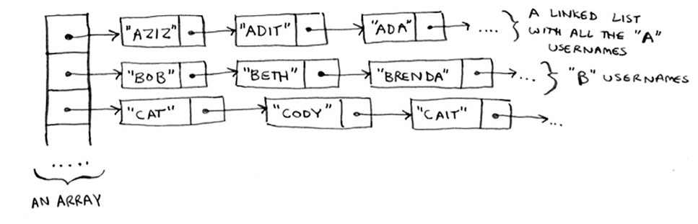

  - Init(tableSize): initializes array 'tableSize' size array with None object to be used to store a linked list. Parameters: table size. Note: think of this as the load factor.
  - hash_func(key): uses item name as a key to compute the hash and returns the result. For this exercise purpose, we will simply sum up each character's ASCII decimals from the item name to compute the hash value. Ex. apple: a (97) + p (112) + p (112) + l (108) + e (101) = 530 Parameters: item name.
  - insert_item(item, price): if the item is already in the list, this method updates the price of it. If the item is not in the list, inserts the item at the end of the linked list on the corresponding array slot.
    - Parameters: item name and price
    - Pseudocode:
        - Compute hash_key(hash_func_result % table size) to identify slot.
        - Check if the given slot is a None object. If None, start a linked list with given parameters.
        - Check if the item is at the hash_key slot. If the item is found, update the price.
        - If the item is not found, create a new node and attach it at the end of the linked list.
  - print_items(): prints items throughout the hash tables with a linked list. Note: try to print as [ (item1, price1) … ] \n by using some combinations of "print(item, end = " ")" at each hash tables slot as shown below.

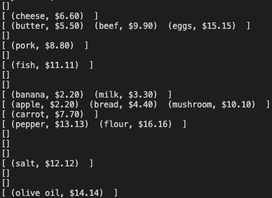

  - find_item(key): returns the price of a given item. If the item is not found, simply use the "returns" statement. Try to reuse the hash_func method. Parameters: item name to be looked up.

- Finally, for your analysis, uncomment the following code provided in the grocery_store_inventory.py and how this correlates with your findings from #4 as N gets increased at 10, 50, 100, 250 and 500. Then provide your observations of run time for each sample size in writing.

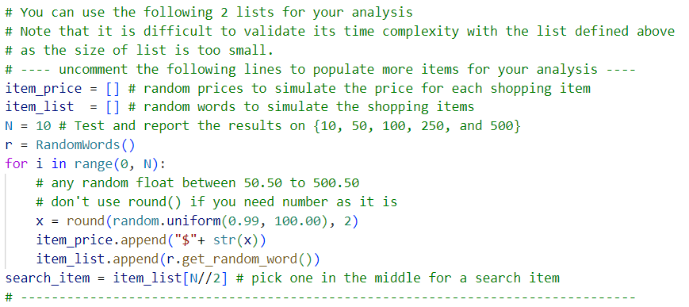

Example output:
